Week 6 Lecture Transcripts notes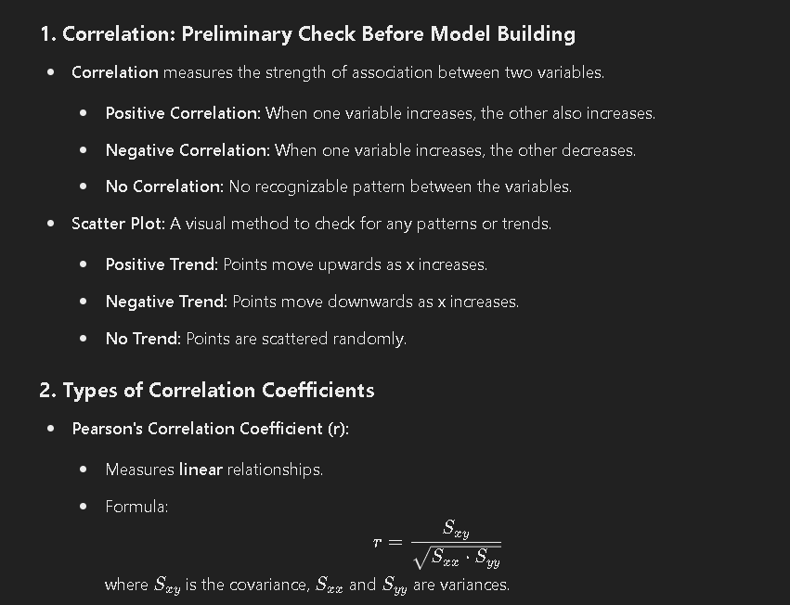

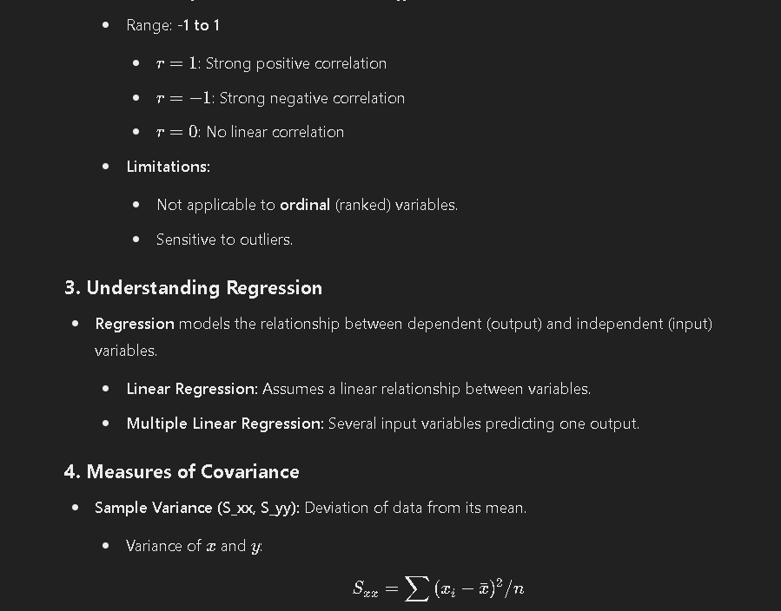

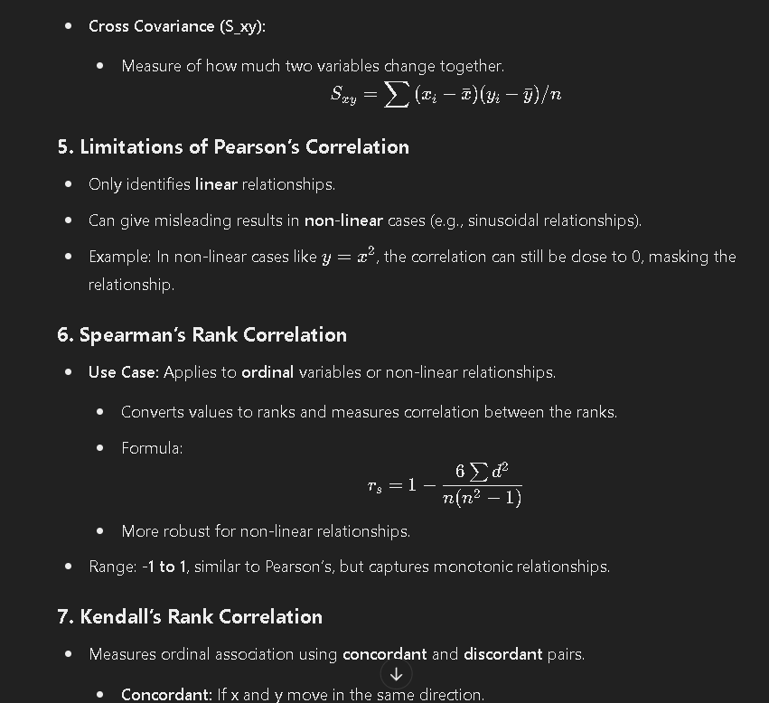

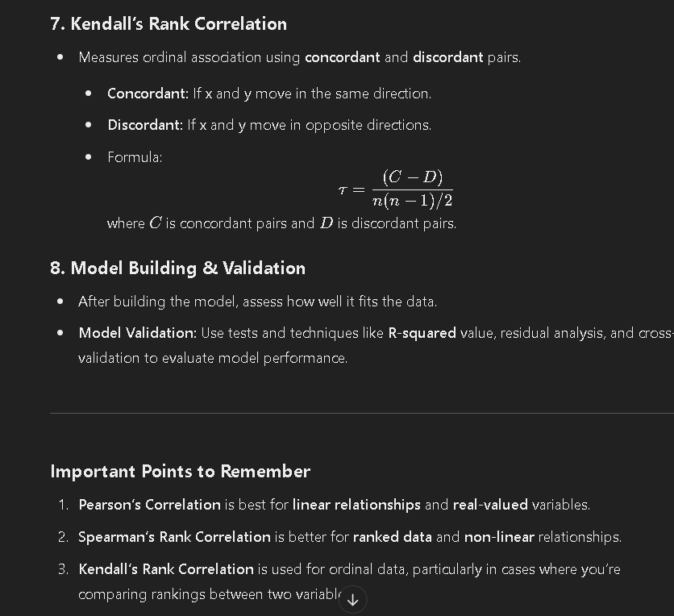

Video 2

Pravalikka 6 transcript brief

# Meeting Summary

**Date:** [Insert Date]

**Session:** Week 6 of Data Science for Engineers Problem Solving Sessions

**Instructor:** Saladi Pravallika, PhD Scholar and Prime Minister Research Fellow, Indian Institute of Science

## Agenda

1. Introduction and Instructions

2. Overview of Regression

3. Ordinary Least Squares (OLS) Regression

4. Testing the Goodness of Fit

5. Hypothesis Testing

6. Practical Examples and R Code Demonstrations

## Key Points Discussed

### 1. Introduction and Instructions

- The session is being recorded.

- Breaks will be given every 30 minutes to an hour.

- Participants can request additional topics to be covered in future sessions.

- Reminder about the last day for exam registration.

### 2. Overview of Regression

- **Supervised Learning:** Involves predicting an output based on input data.

- **Regression:** Predicts continuous output values.

- **Classification:** Categorizes outputs into classes.

- **Types of Regression:**

- **Univariate Regression:** Involves one independent variable.

- **Multivariate Regression:** Involves multiple independent variables.

- **Linear Regression:** Relationship between variables is a straight line.

- **Nonlinear Regression:** Relationship is not a straight line.

### 3. Ordinary Least Squares (OLS) Regression

- **Definition:** A statistical method to estimate unknown parameters in a linear regression model.

- **Equation:** \( Y = \beta_0 + \beta_1X + \epsilon \)

- \( \beta_0 \): Intercept

- \( \beta_1 \): Slope

- \( \epsilon \): Error term

- **Objective:** Minimize the sum of squared errors (SSE).

- **Normal Equations:** Derived by taking partial derivatives of SSE with respect to \( \beta_0 \) and \( \beta_1 \) and setting them to zero.

### 4. Testing the Goodness of Fit

- **R-Squared (R²):** Measures the proportion of variance explained by the model.

- **Formula:** \( R^2 = 1 - \frac{\sum (Y_i - \hat{Y_i})^2}{\sum (Y_i - \bar{Y})^2} \)

- **Interpretation:** Higher R² indicates a better fit.

- **Adjusted R-Squared:** Adjusts R² for the number of predictors in the model.

- **Formula:** \( \text{Adjusted } R^2 = 1 - \left( \frac{(1 - R^2)(n - 1)}{n - p - 1} \right) \)

- **Interpretation:** Higher adjusted R² indicates a better fit, especially when adding more variables.

### 5. Hypothesis Testing

- **Objective:** Test the significance of regression coefficients.

- **Null Hypothesis (H₀):** \( \beta_1 = 0 \) (No relationship between X and Y)

- **Alternative Hypothesis (H₁):** \( \beta_1 \neq 0 \) (There is a relationship)

- **T-Test:** Used to determine if the null hypothesis can be rejected.

### 6. Practical Examples and R Code Demonstrations

- **Univariate Linear Regression:**

- Example data: X = [1, 2, 3, 4, 5, 6], Y = [3, 5, 7, 9, 11, 13]

- Calculated mean, deviations, covariance, and variance.

- Derived coefficients \( \beta_0 \) and \( \beta_1 \).

- Plotted the regression line.

- **Multivariate Linear Regression:**

- Example data with two independent variables X1 and X2.

- Created a 3D scatter plot and regression plane.

- **Outlier Detection:**

- Demonstrated how outliers affect the regression line.

- Showed how to remove outliers and fit a new regression line.

- **Residual Plots:**

- Explained how to interpret residual plots to validate the model.

### Additional Notes

- **Questions and Answers:**

- Addressed various questions from participants regarding regression concepts, calculations, and interpretations.

- **Future Topics:**

- Degrees of freedom and confidence intervals will be covered in upcoming sessions.

## Conclusion

The session provided a comprehensive overview of regression analysis, focusing on OLS regression, goodness of fit, and hypothesis testing. Practical examples and R code demonstrations helped in understanding the application of these concepts. Participants were encouraged to practice the problems discussed and reach out with any questions.